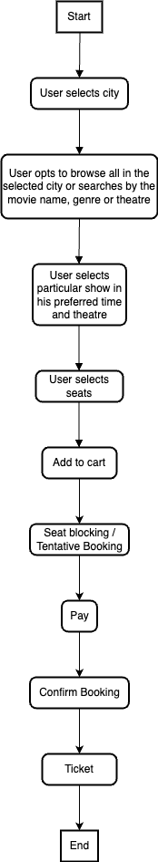
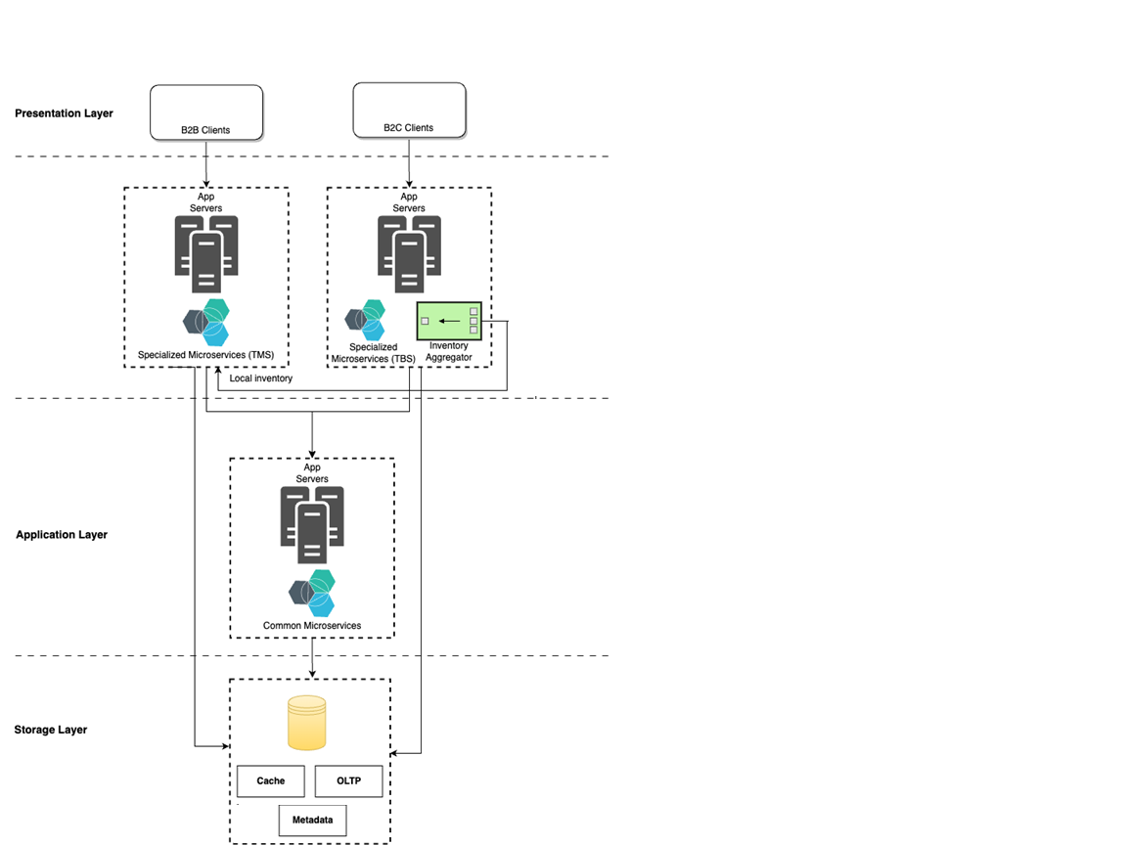
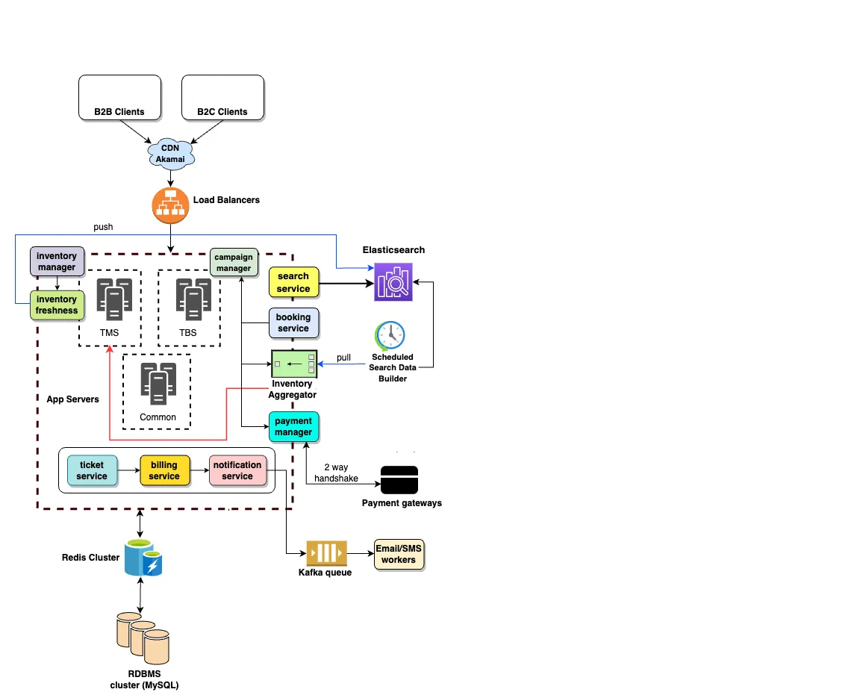
Problem Statement:
We have to build an online movie ticket booking platform that caters to both B2B (theatre partners) and B2C (end customers) clients. Key goals we want to accomplish as part of the solution:
● Enable theatre partners to onboard their theatres over this platform and get access to a bigger customer base while going digital.
● Enable end customers to browse the platform to get access to movies across different cities, languages, and genres, as well as book tickets in advance with a seamless experience.

Requirements:
Provided requirements are as follows, categorized broadly into 2 different types:

Functional:
● B2C users can browse theatres currently running the show (movie selected) in the town, including show timing by a chosen date.
● Book movie tickets by selecting a theatre, timing, and preferred seats for the day.
● The users should be able to select among a list of cities to display a list of movies showing in the area.
● Default date is the current date when the city has been selected.
● Third party payment integrations.
● SMS and email notifications to both B2B and B2C users after successful bookings and cancellations.
● Atomic transactions — only one customer can book a particular seat for a show.
● Financial transactions must be secure.
● Booking platform offers discounts (offers, deals, etc.) on bookings meeting a certain criteria.
● Theatres (B2B users) can create, update, and delete shows for the day.
● Bulk booking and cancellation for B2B users.
● Theatres can allocate seat inventory and update them for the show.

Non-Functional:

● The system should be highly scalable, available, reliable, consistent and fault tolerant.
● Integrate with theatres having existing IT systems and new theatres and
localization(movies).
● How will you scale to multiple cities, countries and guarantee platform availability of 99.99%?
● Movie metadata — description, actors’ info, etc.
● Personalization — user history based suggestions.
● Log management — to debug application errors.
● Monitoring system — errors, alerts, request count, visualization tools etc.
● Business intelligence — near real-time analytics, dashboards, etc.

Assumptions:
● We are having 2 distinct platforms/products each having its own set of functionalities:
1. Online Ticket Booking System (TBS) — Allows B2C end users to search,
book, view and cancel bookings.
2. Online Theatre Management System (TMS) — Allows B2B users, such as
theatre operators, to manage all aspects of their theatre. This includes
onboarding to the platform, configuring their theatre in a specific city, setting up, halls and seats, scheduling shows, managing ticket sales, viewing sales and earnings reports, and performing user management tasks.
● Our TMS platform has a considerable number of theatres and their operators configured within it, using which they manage their daily operations. These operators are commonly known as internal theatres or internal operators, and any shows they configure are referred to as internal inventory.
● There may be some theatres that are not part of our local TMS, either because they have partnered with another organization that provides TMS services or they have their own TMS platform. In order to make their inventory available in our TBS, we need to connect with their TMS, preferably through APIs or gateways.
● Our microservices are developed using Java, SpringBoot, Hibernate and other Java based frameworks/libraries.
● Standalone applications (e.g. a scheduled job) are developed using lightweight programming languages like NodeJS.
● We will be using one of the predominant cloud hosting providers and its managed services — AWS

Booking Process Overview:
While most of the steps in the flow diagram above are easy to understand, our primary focus will be on explaining what Tentative and Confirm booking processes are.

Tentative Booking:
In our highly distributed system, it is crucial to ensure that seat reservation for a particular show occurs in a way that prevents multiple users from reserving the same seat(s). To achieve this, we use a timeout-based block mechanism that temporarily blocks the contested seat(s) for a specified duration, such as 8 minutes. The system then assigns the seat(s) to the user who initiated the request first. Subsequent seat information requests for the same show indicate that the seat(s) are unavailable. If the user fails to confirm their booking and make payment within the allocated window of time, the system automatically releases the seat(s) for other requests
This mechanism needs to be implemented in both our local TMS and third party TMS systems. We have adopted a Redis based blocking technique where we store the inventory and seat(s) information with a defined TTL.

Confirm Booking:
After the seat(s) are successfully blocked, the user proceeds to make payment. On successful completion of the payment (within the given window of time), the system confirms the booking and issues the ticket to the user.

High Level Architecture:
We will be using a 3-tier design model with distinct layers, each having a unique set of responsibilities — presentation, application and persistence.
Presentation layer can be developed using any modern JS frameworks like NodeJS, ReactJS, etc.
Application layer implements a microservices-oriented architecture. Each microservice implements a hexagonal design pattern for better adaptability, extensibility and easier maintainability.

Deployment Strategy:
We will employ a hybrid strategy for this deployment. we have specific microservices stack catering to each product separately. Common microservices are bundled into a single set of AWS infrastructure. This reduces duplicate and redundancy across common functionalities, while maintaining product specific isolation of each.

Low Level Architecture:
The high-level architecture previously illustrated has been extended with additional components to meet our functional and non-functional requirements.The diagram includes the core components and some of the key microservices as accurately as possible. Below, we provide further details on each component.

Components:

● Content Delivery Network (CDN): To ensure faster delivery of media
(images/videos), we have used a CDN provider Akamai. Modern CDNs also provide many security features against possible threats such as DDoS.
● Load Balancers: We use a load balancer to distribute the load on the server and to keep the system highly concurrent when we are scaling the app server horizontally. We can configure ELB (Layer 4 in OSI) based on specific app server needs.
● App Servers: We have a horizontally scaled distributed network of app servers running different containerized microservices within them. They represent the heart of our overall system and ensure smooth running of the business.
● Elasticsearch: Elasticsearch is used to support the search APIs on our platform (to search movies or shows). Elastic search is distributed, and it has RESTful search APIs available in the system. It can be also used as an analytics engine that works as an App-level search engine to answer all the search queries from the front-end. However, for the sake of API wise monitoring purposes, we will put it behind a search service layer
consisting of target groups and their instances.
● Scheduled Search Data Builder: It is a crawler that runs periodically aggregating all the available inventory for a predefined number of days, and copies to Elasticsearch. We need to pre-build our search data as we expect the volume of search is going to be much higher than other user activities on our platform.
● Payment Gateways: We are integrated with multiple major third party payment solutions, with whom a two way handshake mechanism enables our B2C customers to pay and book tickets.
● Redis Cluster: We have a set of Redis clusters each having their own set of nodes(or replicas), configured on the basis of use cases. It is primarily being used for app server caching, storing movie metadata(description, genre, languages, actors’ info, release date, film board certification number, user reviews and comments, etc) and for the seat-blocking mechanism, during tentative booking(prior to payment).
● RDBMS cluster (OLTP): Since the booking process is quintessentially a transactional one, we need to enforce strict ACID compliance. Also, we need to store many other relational information about operators, theatres, halls, seats, etc for our local TMS. To achieve both the goals, we have used MySQL in this exercise (but PostgreSQL, Oracle, etc can also be used).
● Messaging Queue: In order to optimize the booking process for fast response time and efficient handling of requests, we should adopt an asynchronous approach for sending notifications. This can be achieved by utilizing a message-queue system based on Kafka. The notification service will generate messages and publish them to the queue, while consumers of the queue will be responsible for delivering emails, SMS, and push notifications to the intended recipients.

Microservices:
- ● Search: It is the primary interface that allows both B2B and B2C users to search for movies. It retrieves the necessary data from Elasticsearch using RESTful APIs and adds any customizations such as filters, ongoing campaigns/deals, etc., before returning the results to the clients. We can isolate the search services for our TMS and TBS at the infrastructure/deployment level, which allows us to scale their infrastructure independently based on traffic.
● Booking: It is our core service that is responsible for managing the entire booking process. This includes fetching seat information, reserving seats, initiating payments, confirming bookings upon successful payment, and initiating the ticketing workflow. Unlike our search function, the booking service does not rely on pre-cached data, but instead makes real-time calls to both local and remote TMS systems via an inventory aggregator.
● Inventory Aggregator: It’s responsibility is to combine the data from both local and remote TMS systems, transform the data to system compatible format if necessary, and return the result to its caller.
● Payment Manager: It is responsible for all the payment related workflows and interfacing with the available payment gateways.
● Inventory Manager: It is our TMS system’s core component which enables B2B operators to manage their inventory. This includes configuring theatres, halls, shows, fares, seat layouts, campaigns (offers), and employee management. The operators can also define seat-level quotas for shows that are meant for their counter/offline bookings. The inventory management service is the heart and soul of our TMS system.
● Inventory Freshness: It updates Elasticsearch with any changes (creation, updates, or deletions) made to the inventory by operators using our TMS console. This ensures that our search data is always up-to-date. Additionally, we can use a webhook to update the database of any third-party aggregators if needed.
● Campaign Manager: It enables the configuration of offers and deals for both our internal business team and theatre operators. Booking platform offers in selected cities and theatres
    - 50% discount on the third ticket
2. Tickets booked for the afternoon show get a 20% discount
● Ticket: Manages all operations related to the ticketing workflow, including the creation and modification of tickets, as well as triggering subsequent workflows such as billing, notifications, and invoicing for both booking and cancellation events.
● Billing: It is our core financial service that is responsible for maintaining the organizational ledger for every transaction within our system. It records the credit and debit of various components, such as fare, commission, offers, and more, between the three parties involved: the organization, the theatre operators, and the end users. It is crucial for our internal finance team to accurately assess timely payouts to the relevant
stakeholders based on this information.
● Notification: As the name suggests, it manages all the different types of notifications triggered by the system.
● Unique inventory identification: A unique inventory available on a platform refers to the specific screening of a movie by a particular theatre of a city on a particular day and time.
○ In Which city (city ID)
○ By Which operator (operator ID)
○ In Which theatre (theatre ID) — an operator can have multiple theatres within a city
○ At Which hall (screenNumber ID)
○ Which movie (movie ID)
○ On Which day (timestamp)
○ At Which time (timestamp)
So essentially, we need 6 identifiers to uniquely identify a show. This information exists within the TMS platforms and can be combined to generate a unique identifier.
● Localization: Our system stores the movie metadata which is used to order the search results by the regional language (regional language films feature on top). To identify a regional language based on the user selected city, we maintain a mapping of different regions(region ID) and their native languages(language ID). We can also coalesce multiple regions together to deliver a broader demographic personalization. We precompute all this data and store it in the redis cache for better fetch-performance. This
data is also periodically updated, as and when new regions get added or there is a demographic shift of the speakers between the regions.
● Log Management: We can use our ELK setup to store and capture app server logs and provide holistic error analysis in Kibana dashboard. Furthermore, we can setup other analysis dashboards which can be helpful in quickly identifying the faulty services during an error situation.
● Monitoring: We can setup alerts in Cloudwatch (for AWS) or similar other monitoring services provided by other cloud providers.

Core APIs
Considering the extensive requirements and considerations outlined above, it is evident that the system involves various complexities. However, it is not feasible to cover all of these elements within the scope of this article. Thus, we will concentrate on highlighting only the essential functional APIs that are critical to the system.
1. getOperatingCities()
Method: — GET
Returns: —List<City> cityList — List of City objects, each containing information such as the city name, state and country details, latitude and longitude coordinates, and other relevant information.
2. getAvailableInventory(SearchCriteria criteria, Date date, Long cityId)
Method: — GET
Parameters: - SearchCriteria is an enum with 3 values: MOVIE, THEATRE, GENRE.
If null, default city wise search will be considered.
- date — for which user is searching, will consider current date if null.
- cityId — City Id of the city for which a user is searching shows
Returns: —List<AvailableInventory> availableInventoryList — List of AvailableInventory objects, where each object contains details of all available shows that meet the specified search criteria in the given city. These details include the theatre name, movie name, timings, screen type, amenities, and other relevant information.
3.getSeatInformation(BigInteger inventoryId)
Method: — GET
Parameters: —
- inventoryId — A unique inventory id generated by technique we previously saw.
Returns: — SeatInformation — Object a list of seat objects, each of which contains crucial information such as fare, GST, seat type/tier, availability, x-y-z coordinates (for constructing actual layout by clients), and more.
4. doTentativeBooking(TentativeRequest request)
Method: — POST
Parameters: —
- request — Tentative request object with all necessary details populated.
Sample request JSON: —
Returns: — String blockKey — A unique block ID generated for this booking.
5. doConfirmBooking(ConfirmRequest request)
Method: — POST
Parameters: —
- request — Confirm booking request with necessary details populated.
Returns: —Ticket ticket — Final ticket object with details such as ticket number , seat details, show timings, etc.
7.cancelTicket(CancellationRequest request)
Method: — POST
Parameters: —
- request — Cancel request with necessary details populated.
Returns: — CancellationResponse response — Response object with cancellation related details such as cancellation charges, refund amount, seats cancelled, booked seats (in case of partial cancellation i.e. cancelling few seats among all originally booked) and other relevant information.

Database Schema:
Given the complexities involved in our system, it is not feasible to provide an exact schema for our database(s) and their tables. However, we can outline some key areas on which we can focus when designing our schema. These include:
● User management: This includes tables for storing user information, such as name, email, password, and other relevant details.
● Movie and show information: This includes tables for storing information about movies, shows, theatres, and screens, such as show timings, theatre name, screen type, and amenities.
● Inventory management: This includes tables for storing information about available seats and their status, such as seat type, fare, availability, and coordinates.
● Transactional data: This includes tables for storing information about ticket sales, such as ticket number, seat details, and show timings.
● City information: This includes tables for storing information about cities, such as name, state and country information, and latitude and longitude coordinates.
By focusing on these key areas, we can design data base schema that meets our functional and non-functional requirements and supports the efficient storage and retrieval of data in our system.

